eCMS MANUAL

Resource Management User Manual

Department of Revenue and Customs
Ministry of Finance
Table of Contents
1. Introduction 1
1.1 Resource Administrator (RA) 1
1.1.1 Login as Resource Administrator 1
1.2 Resource Supervisor 4
1.2.1 Login as Resource Supervisor 4

Introduction
CMS use the resource management to assign officers to perform certain business functions like document verification, inspection on a specific declaration etc. The assignment is linked to a specific business transaction. The manager/supervisor of the customs office will configure resource management and can manually assign officers to task.

Resource Administrator (RA)
The resource administrator will have a dashboard where in one time configuration is done Human Resource setup is done on National level.

Login as Resource Administrator

Click on HR Management:

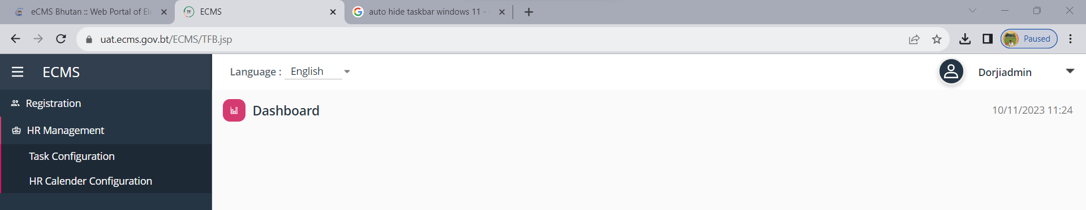.
- Task Configuration: setup of the task and the roles of the assigned modules. The configuration contains modules, Task name, Algorithm, and due date.


  - Select Task Configuration > Task list will display on dashboard.
  - If you want to modify, click on three dots ( )on the right side of the list or grid.
  - If want to add, click on Plus Button ( )on the top of the list.
  - To save the record, Click on Update Button () or to cancel record, click on reset button ()
  - Algorithm is default by system as Round Robin

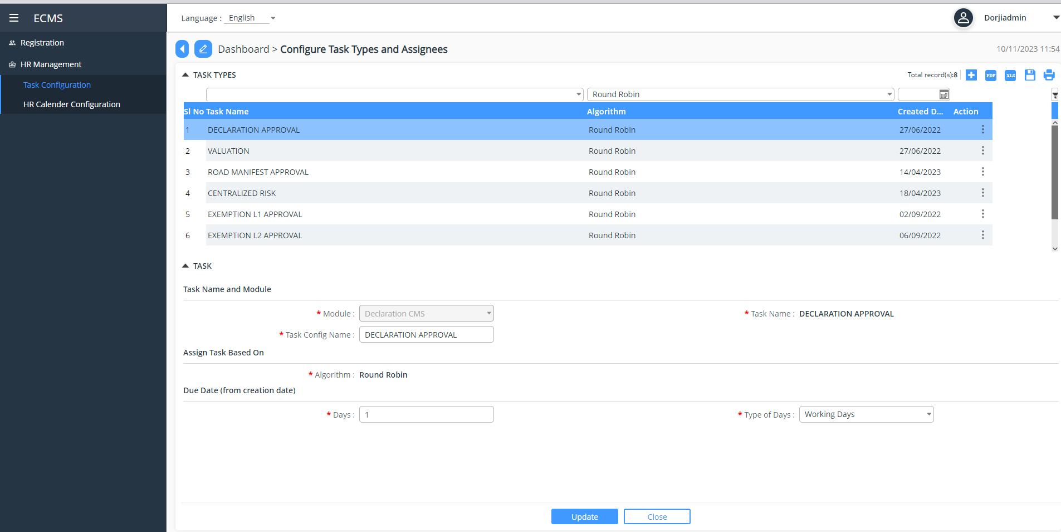

- HR Calendar Configuration: in the calendar year configuration, there are 4 tabs which requires setup.
A planning calendar is a set of working and non-working days specified for a time interval, including holidays and special periods defined in the underlying factory calendar.

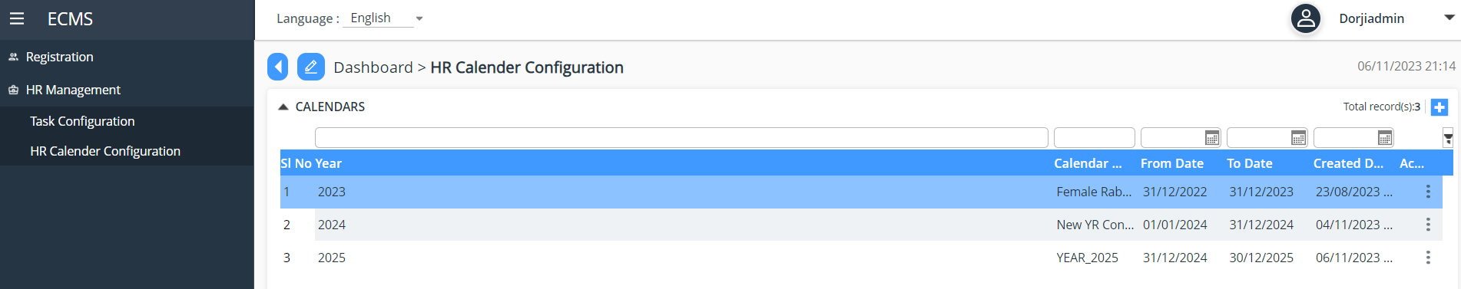

- Calendar

- Click on + button to add in the Calendar
- Calendar: To set coming year for all Regions and Customs Stations.
- To Create a year, Click on Plus Button ( ) on the top of the list. And which year you want create and defined the Year and name of Calendar. Fill up the Start date and End Date.
- Click on Update Button () to save the records.
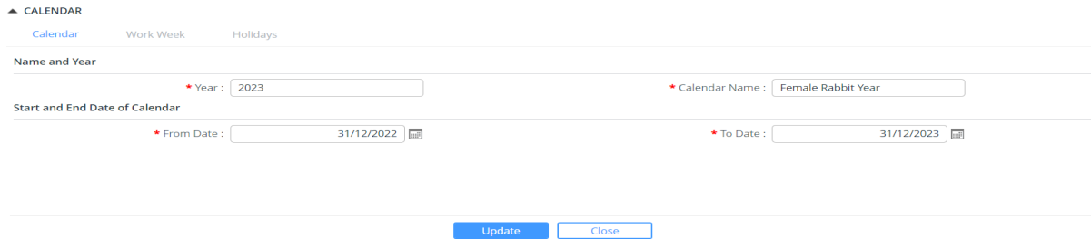

- Work week:
- Click on the Tab of Work Week, It will display from Monday to Saturday.
- If you want to make non-working day, click on three dots ( ) on the right side of the list or grid. Under Is workday, drop-down list will be list as Yes or NO. Select what value you want to defined.
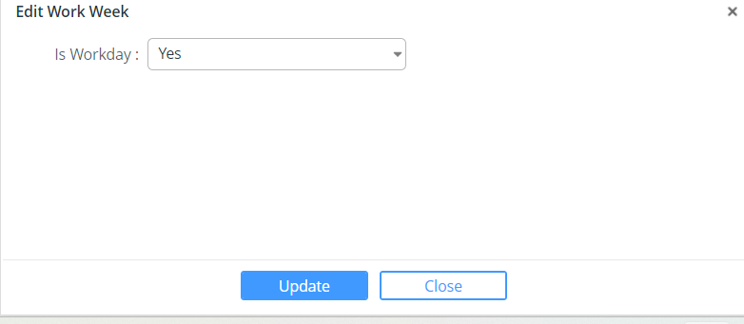
- Click on Update Button () to save the records.
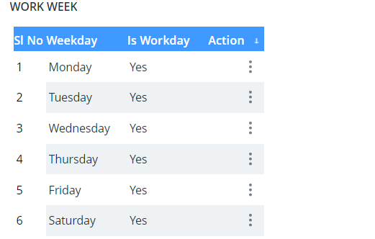
- Holidays: to configure the National Holidays of the Nation, once you create that date as holiday, all submission goes to pending task and system will not assign any tasks to the Officers.
- To create Holiday, Click on Plus Button ( ) on the top of the list. Fill up the Name of Holiday and defined the date. Click Check button for active.
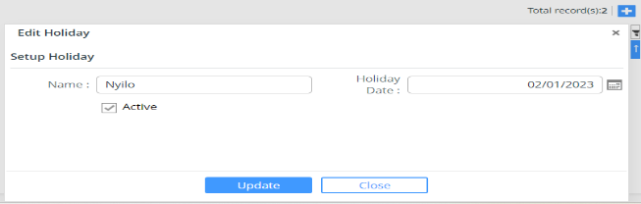
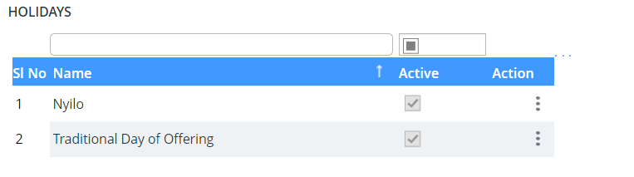
- Click on Update Button () to save the records.

Resource Supervisor

Login as Resource Supervisor
Scheduling more people during the busiest time of day and balancing shifts so that the staff does not feel overworked. Managing employee schedules also means being flexible and prepared when employees need to make changes, such as requesting a day off, calling in sick or handling a family emergency.

Click on HR Management

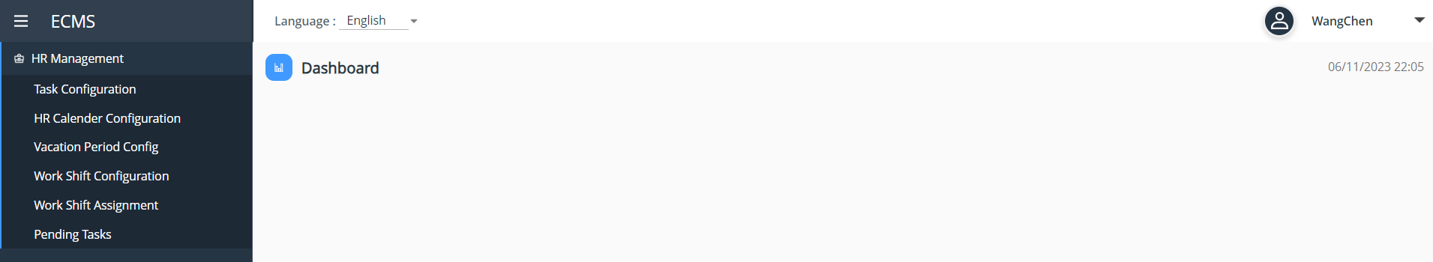

Additional to the Resource Administration module Task Configuration and Calendar Configuration, the below are the moules are available:

- Vacation Period Config
- To create Vacation Period. Click on Plus Button ( ) on the top of the list. Fill up the user. Click Check button for active.
- Click on Update Button () to save the records.

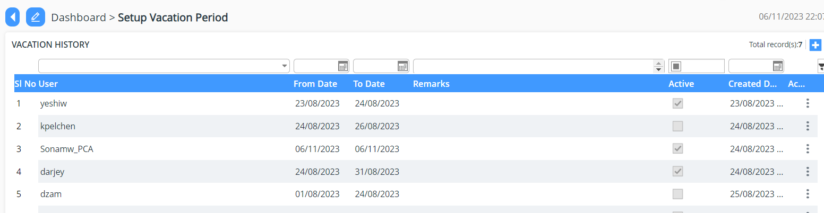
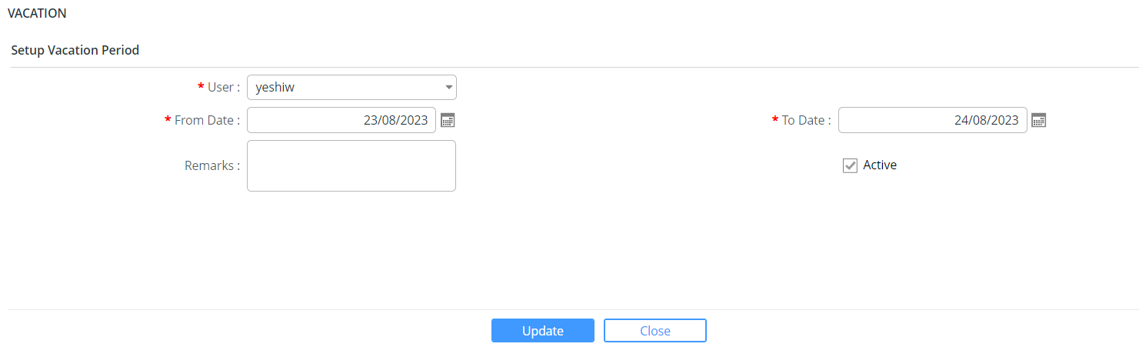

- Work Shift Configuration
- To create work shift, Click on Plus Button ( ) on the top of the list. Fill up the Name of Holiday and defined the date. Click Check button for active.
- Click on Update Button () to save the records
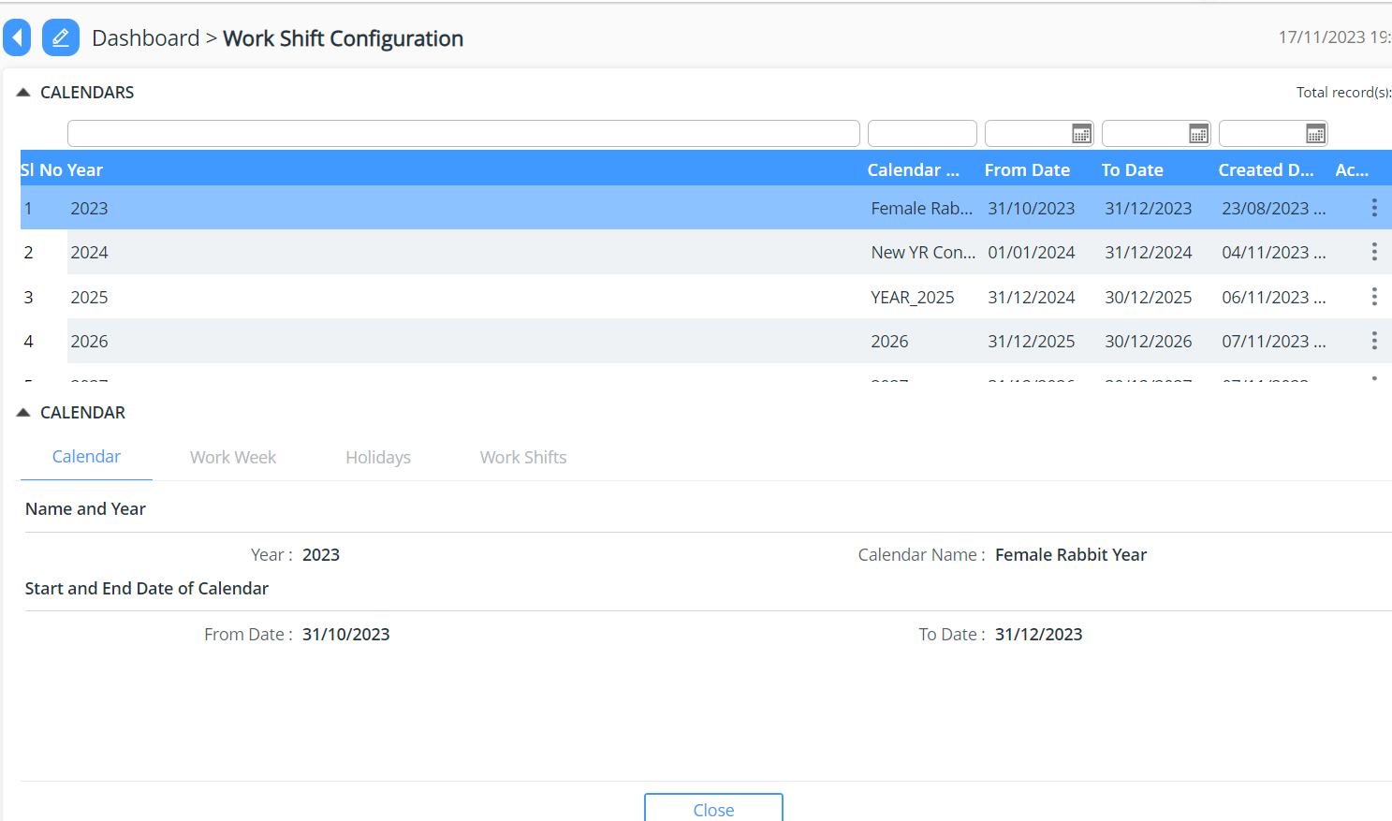

- Work Shifts
- To create work shift, Click on Plus Button ( ) on the top of the list. Fill up the Name of Holiday and defined the date. Click Check button for active.
- Click on Update Button () to save the records

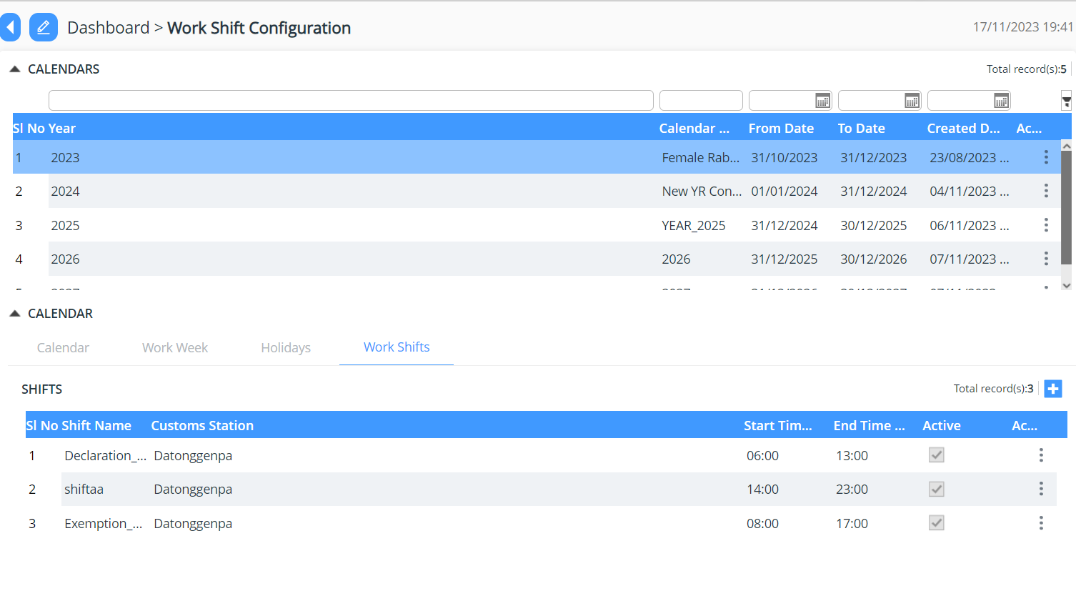

- Shift Assignment

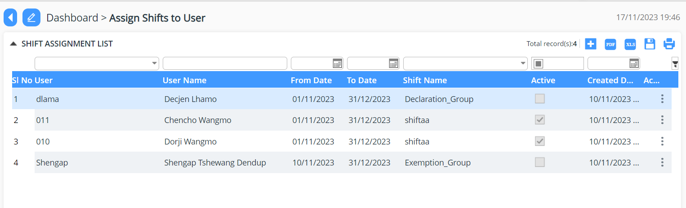
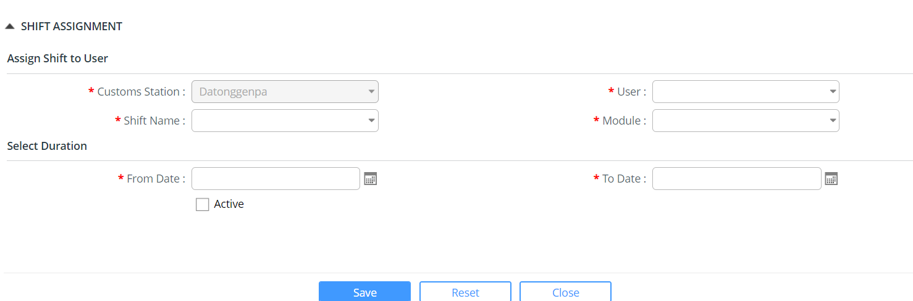

- Pending Tasks: This module will list the task pending task.
- Select any of the task by double tabbing the line item.
- Fill in the details require and update the same.

